

Final Project Report Template

- Introduction
  - Project overviews
    - The project basically classifies the dog breeds using transfer learning.In this project CNN Architectures like VGG-16 , Resnet-50 , Inception and Xception.
  - Objectives
    - The objective of the project is to classify the different breeds of dogs so as to solve the real-world problems.

- Project Initialization and Planning Phase
  - Define Problem Statement
    - The problem statement for the following project can be any of the below two:
      - To create an online platform to categorize the dog breed available for adoption based on the uploaded image.
      - A veterinarian needs assistance in identifying the breed of the dog brought in for health checkup.

  - Project Proposal (Proposed Solution)
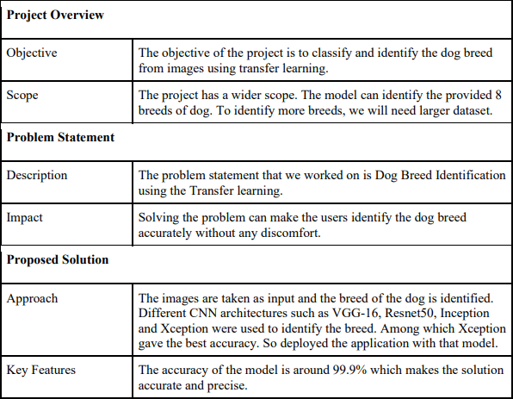

  - Initial Project Planning
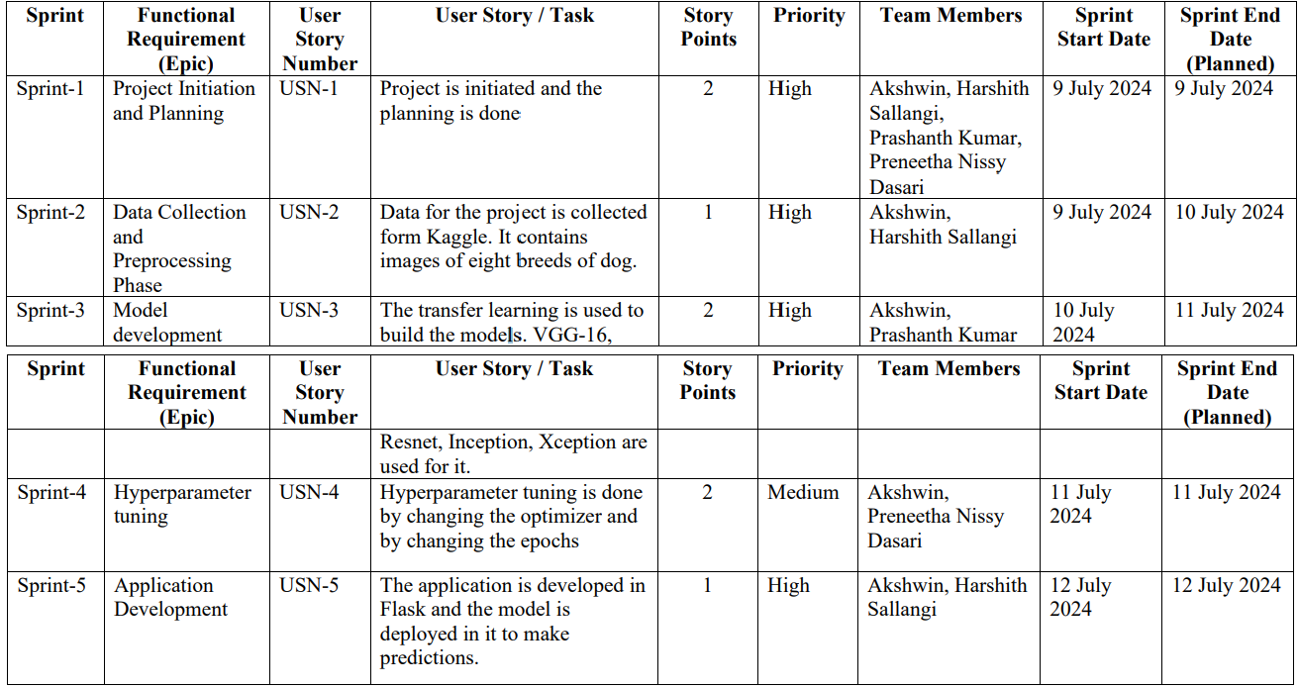

- Data Collection and Preprocessing Phase
  - Data Collection Plan and Raw Data Sources Identified

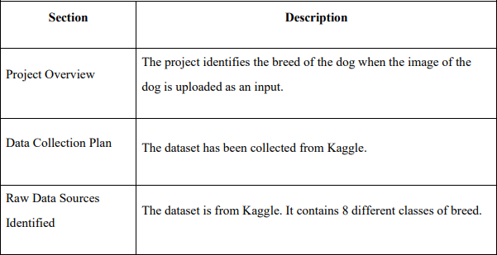
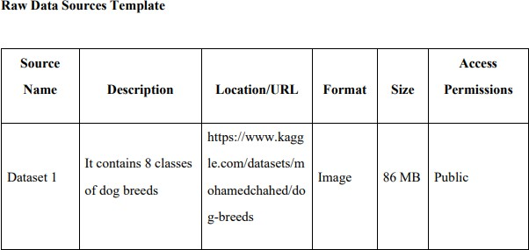

  - Data Quality Report

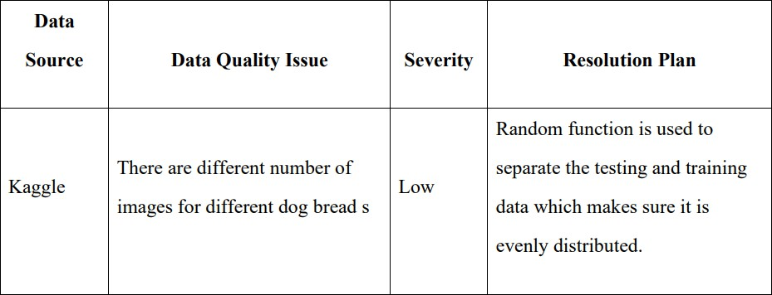
  - Data Preprocessing
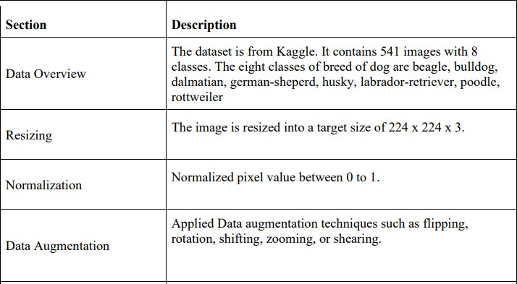
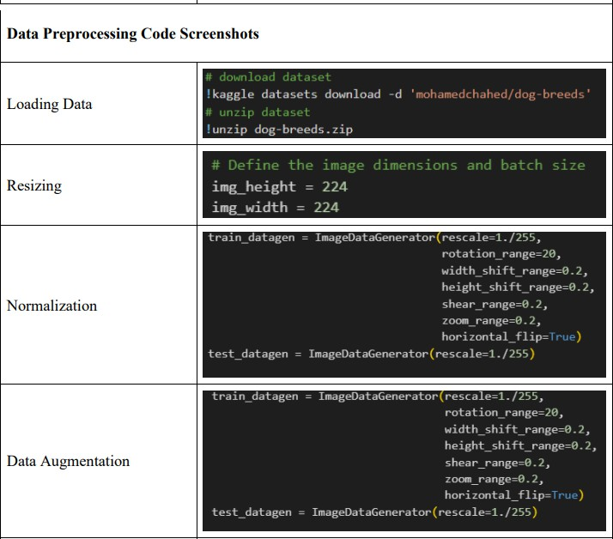

- Model Development Phase
  - Model Selection Report
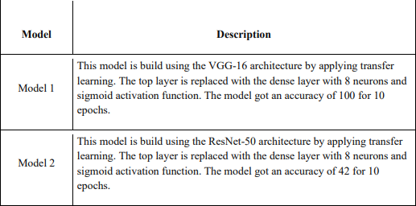
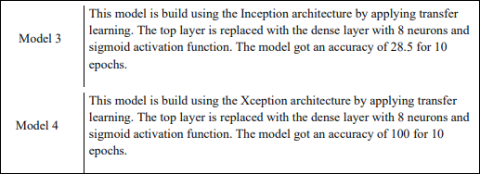

  - Initial Model Training Code, Model Validation and Evaluation Report Initial Model Training
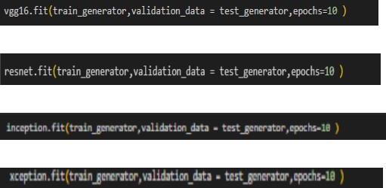

Model Validation and Evaluation Report
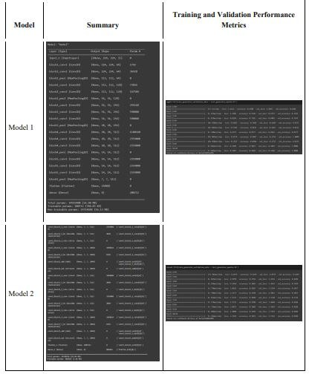
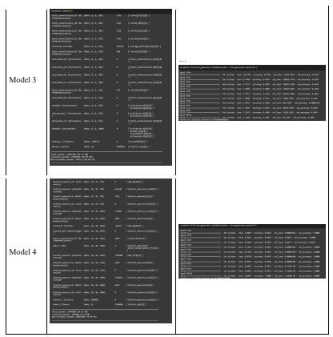

- Model Optimization and Tuning Phase
  - Tuning Documentation
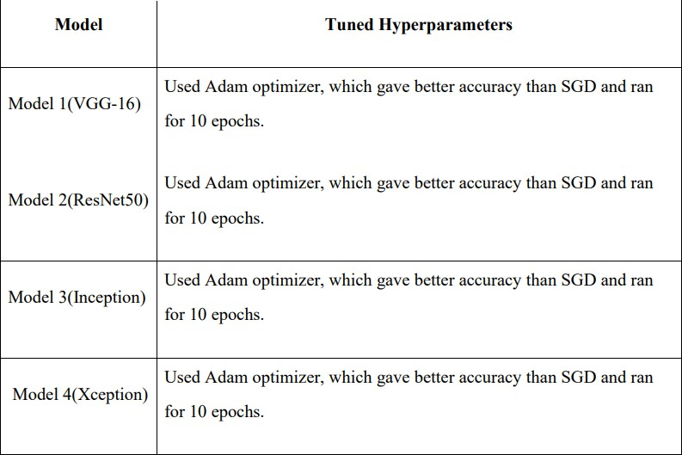
  - Final Model Selection Justification

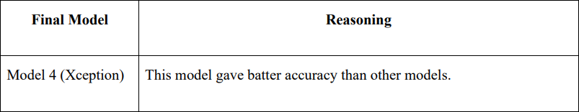
- Results
  - Output Screenshots

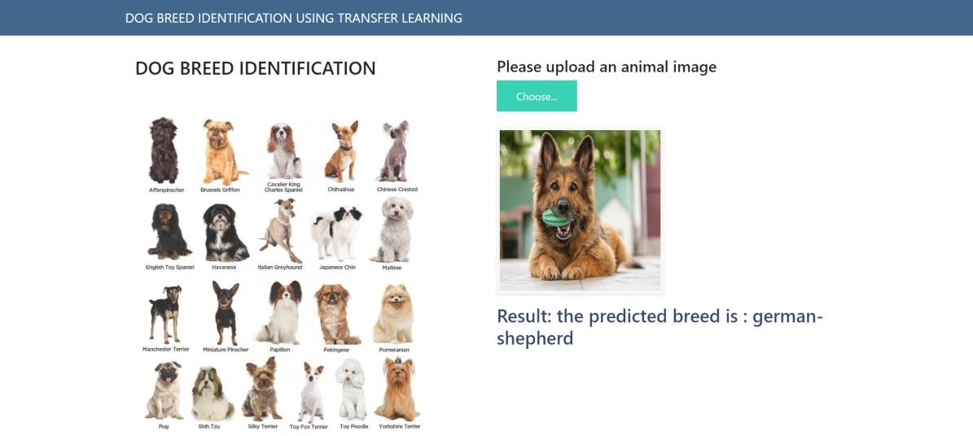

- Advantages & Disadvantages

Advantages:

- Transfer learning leverages pre-trained models on large datasets (like ImageNet), allowing for quicker convergence and significantly reducing the time needed for training.
- Pre-trained models have learned rich feature representations, which can enhance the accuracy of the classification task, especially when dealing with limited data.
- Transfer learning can achieve good performance even with smaller datasets, which is beneficial if you don’t have access to a large dataset of dog breeds.
- Using complex, deep networks (like ResNet, VGG) becomes feasible without the need to train them from scratch, making advanced architectures accessible.
- The features learned from a broad dataset can help the model generalize better to different types of dog breeds, improving robustness.

Disadvantages:

- Pre-trained models might not be specialized for the task of dog breed classification and may include features irrelevant to this specific task.

- There might be a difference between the source dataset (e.g., ImageNet) and the target dataset (dog breeds), causing a performance drop due to domain shift.

- Pre-trained models are often large and computationally expensive, which might not be suitable for deployment in resource-constrained environments.

- If the target dataset is very small, there's a risk of overfitting to the small dataset despite the use of pre-trained models.
- The quality of your results is heavily dependent on the pre-trained model you choose. If the pre-trained model is not well-suited to your specific task, performance can be suboptimal.

- Conclusion
- The project uses transfer learning to identify the breed of the dog.
- The Xception architecture gave the best result.
- So, it is used for deploying in the Flask application

- Future Scope

Enhanced Model Accuracy:

- Continued improvements in deep learning algorithms and architectures could lead to even higher accuracy in classifying dog breeds.

Real-Time Classification:

- Development of lightweight, efficient models that can run on mobile devices, enabling real-time classification through smartphone apps.

Integration with IoT:

- Combining dog breed classification with Internet of Things (IoT) devices, such as smart collars or home cameras, for continuous monitoring and identification.

Explainable AI:

- Incorporating explainability features to provide users with insights into how the model makes its decisions, increasing trust and usability.

- Appendix
  - Source Code import os
import shutil import random import numpy as np
import matplotlib.pyplot as plt import tensorflow as tf
from tensorflow.keras.layers import Dense from tensorflow.keras.models import Model
from tensorflow.keras.preprocessing import image
from tensorflow.keras.preprocessing.image import ImageDataGenerator

train_dir = 'train' test_dir = 'test' img_height = 299
img_width = 299
batch_size = 32

train_datagen = ImageDataGenerator(rescale=1./255,
rotation_range=20, width_shift_range=0.2, height_shift_range=0.2, shear_range=0.2, zoom_range=0.2, horizontal_flip=True)
test_datagen = ImageDataGenerator(rescale=1./255)

train_generator = train_datagen.flow_from_directory(train_dir,
target_size=(img_height, img_width), batch_size=batch_size, class_mode='categorical', color_mode='rgb')

test_generator = test_datagen.flow_from_directory(test_dir,
target_size=(img_height, img_width), batch_size=batch_size, class_mode='categorical', color_mode='rgb')

from tensorflow.keras.applications.xception import Xception from tensorflow.keras.layers import Dense , Flatten
from tensorflow.keras.models import Model
xception= Xception(include_top = False,input_shape=(299,299,3))

for layer in xception.layers: print(layer)
for layer in xception.layers: layer.trainable = False

x = Flatten()(xception.output)
output = Dense(8,activation = 'softmax')(x)

xception= Model(xception.input,output)

xception.compile(loss = 'categorical_crossentropy',optimizer = 'adam',metrics=['accuracy']) xception.fit(train_generator,validation_data = test_generator,epochs=10 )

  - GitHub & Project Demo Link

    - Github link
      - https://github.com/akshwin/Dog-Breed-Identification-Using- Transfer-Learning

    - Project demo link
      - https://www.youtube.com/watch?v=60b7-n83Vm8&t=16s

